Count Items in a List
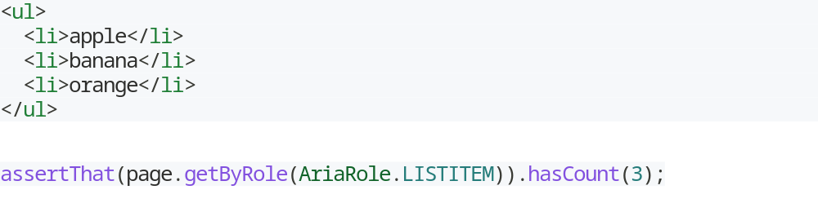

Assert All Text In a List
- You can assert locators in order to find all the text in a list.

Get a Specific Item
- Use the Page.getByText() method to locate an element in a list by its text content and then click on it.
- Use the Page.getByTestId() method to locate an element in a list.
- If you have a list of identical elements, and the only way to distinguish between them is the order, you can choose a specific element from a list with Locator.first(), Locator.last() or Locator.nth().
Chaining Filters

